**Lab No 12**

**Name : Muhammad Faizan Reg. No. : 21-NTU-CS-1258**

**(Q1)**

#include<iostream>

using namespace std;

int main()

{

int x,y,*p1,*p2,**p_1,**p_2;

float avg;

p1=&x;

p2=&y;

cout<<"Enter First Number ";

cin>>*p1;

cout<<"Enter Second Number ";

cin>>*p2;

p_1=&p1;

p_2=&p2;

avg=(**p_1+**p_2)/2;

cout<<"Average is "<<avg;

}

**Output**

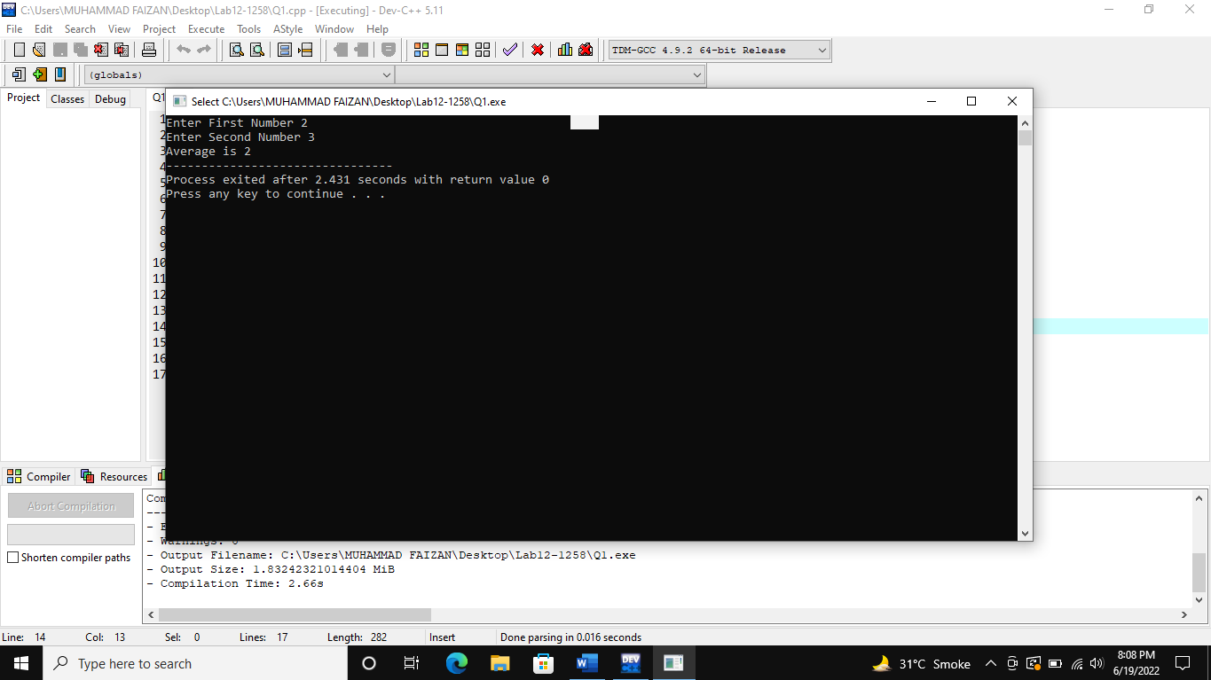

**(Q2)**

#include<iostream>

using namespace std;

int main()

{

char *p1,*p2,**p_1,**p_2;

p1=new char;

p2=new char;

*p1='A';

*p2='B';

p_1=&p1;

p_2=&p2;

cout<<**p_1<<endl;

cout<<**p_2<<endl;

return 0;

}

**Output**

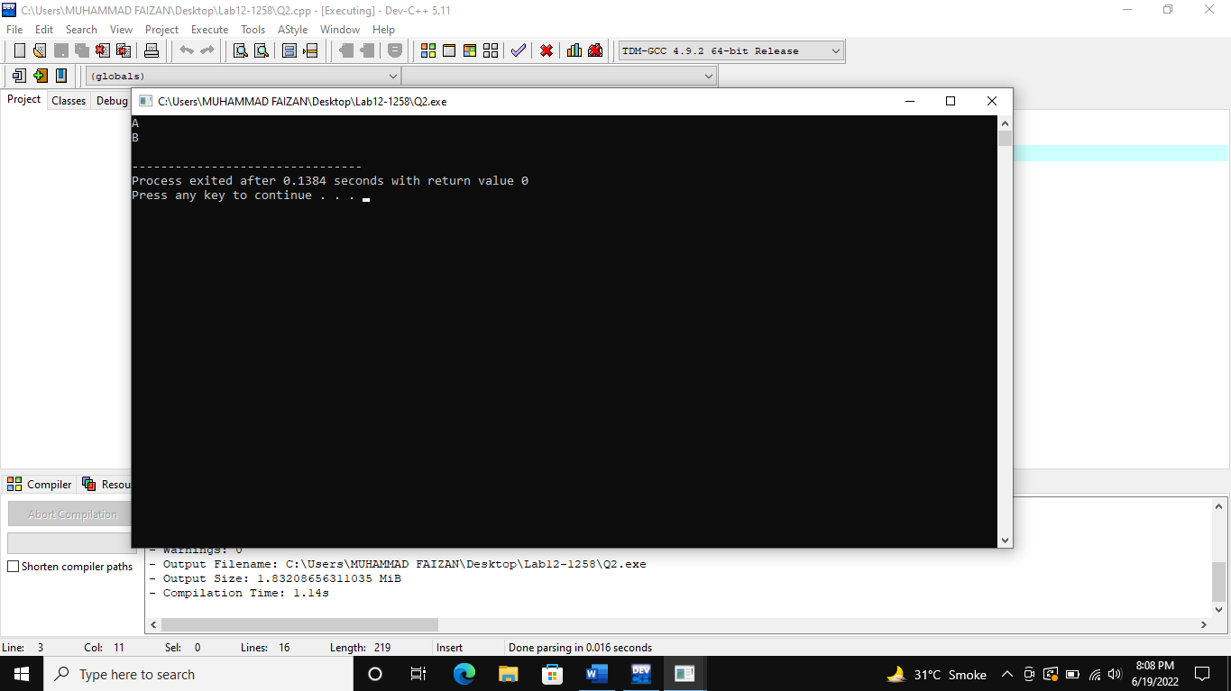

**(Q3)**

#include<iostream>

using namespace std;

int main()

{

int sum=0,*p1,*p2,**p_1,**p_2;

p1=new int;

p2=new int;

*p1=44;

*p2=34;

p_1=&p1;

p_2=&p2;

cout<<**p_1<<endl;

cout<<**p_2<<endl;

return 0;

}

**Output**

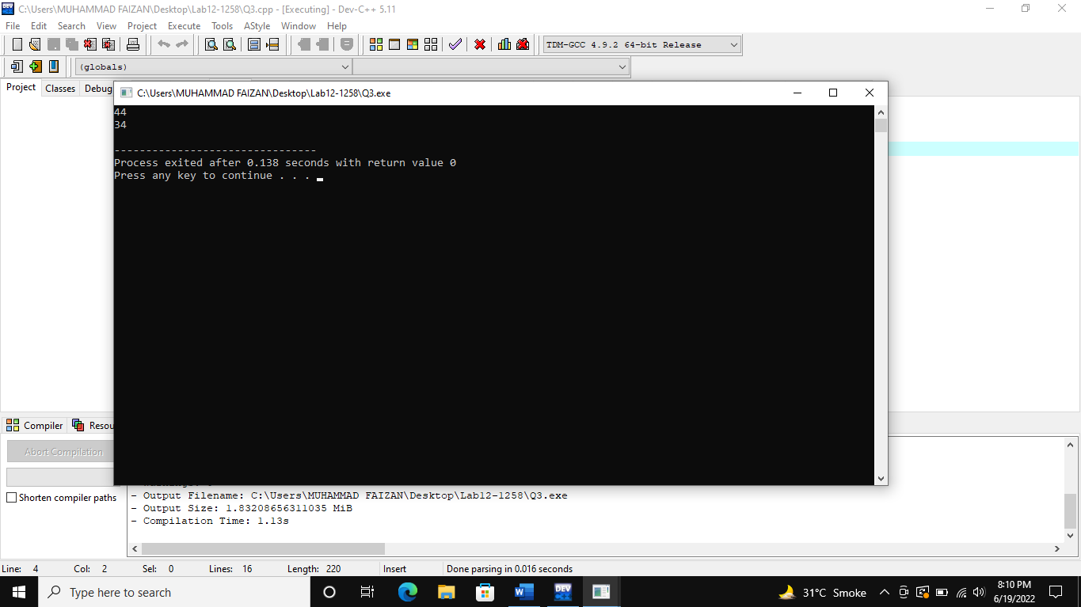

**(Q4)**

#include<iostream>

#include<cstring>

using namespace std;

class student

{

public:

string RegNumber;

string Name;

string Semester;

string Degree;

string Department;

float CGPA;

};

int main()

{

student obg1;

student obg2;

student obg3;

obg1.RegNumber="21-NTU-CS-1258";

obg1.Name="Muhammad Faizan";

obg2.Semester="Second";

obg2.Degree="BS Computer Science";

obg2.Department="Computer Science";

obg3.CGPA=3.33;

//output

cout<<"RegNumber: "<<obg1.RegNumber<<endl;

cout<<"Name: "<<obg1.Name<<endl;

cout<<"Semester: "<<obg2.Semester<<endl;

cout<<"Degree: "<<obg2.Degree<<endl;

cout<<"Department: "<<obg2.Department<<endl;

cout<<"CGPA: "<<obg3.CGPA<<endl;

}

**Output**

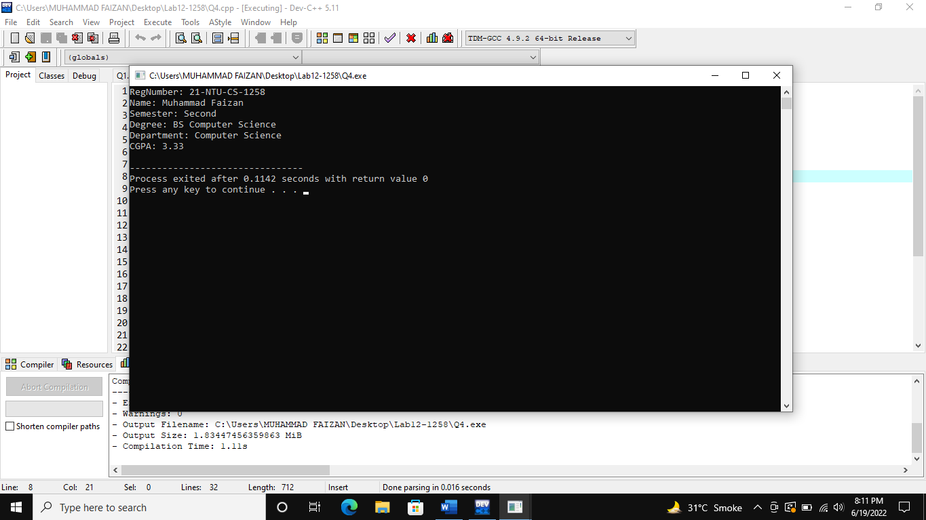

**(Q5)**

#include<iostream>

#include<cstring>

using namespace std;

class student

{

public:

string Name;

string Department;

int Age;

};

int main()

{

student obg1;

student obg2;

obg1.Name;

obg2.Department;

obg2.Age;

//output

cout<<"Name: ";

cin>>obg1.Name;

cout<<"Department: ";

cin>>obg2.Department;

cout<<"Age: ";

cin>>obg2.Age;

cout<<"======================"<<endl;

cout<<"Name of employee: "<<obg1.Name<<endl;

cout<<"Department of employee: "<<obg2.Department<<endl;

cout<<"Age of employee: "<<obg2.Age;

return 0;

}

**Output**

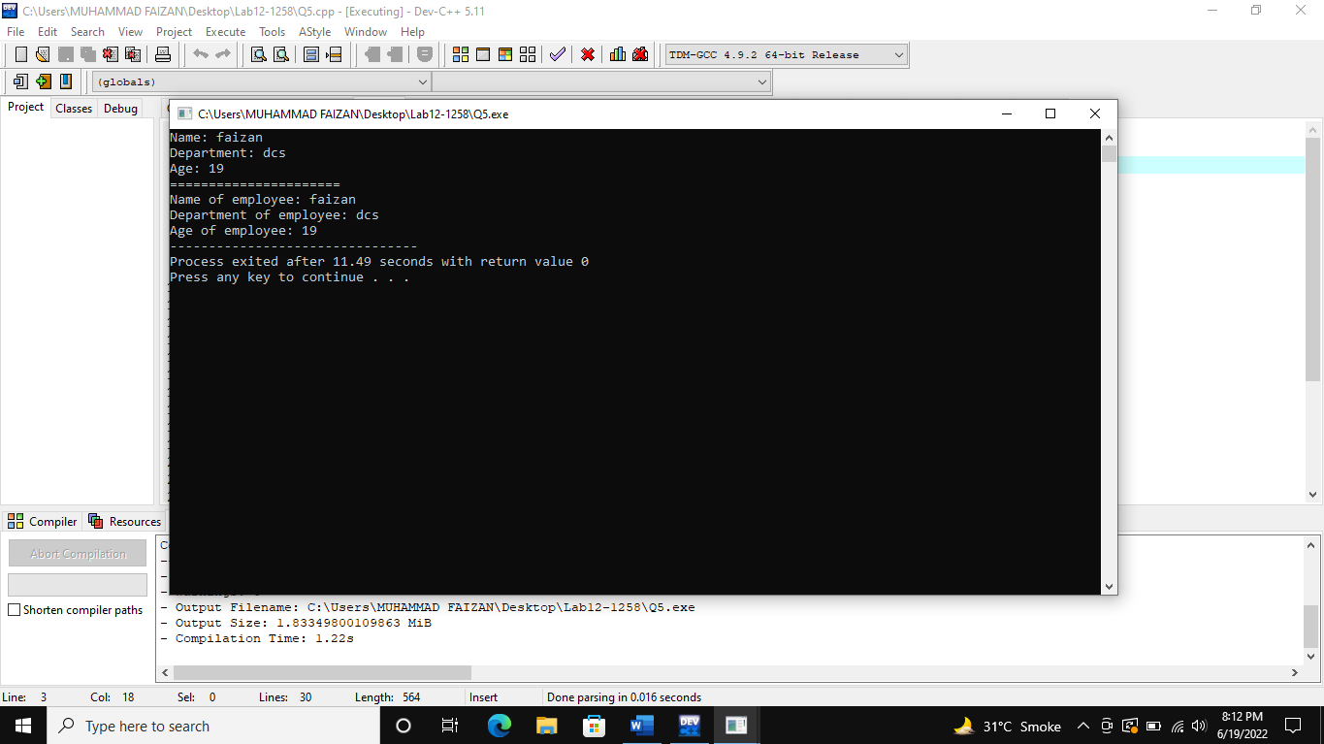

**(Q6(a))**

#include<iostream>

using namespace std;

struct Teacher {

int ID = 0;

char name[50];

char HQ[100];

int scale = 0;

};

void input(Teacher& a)

{

cout << "Enter the ID: " << endl;

cin >> a.ID;

cin.ignore();

cout << "\nEnter the Name: " << endl;

cin.getline(a.name, 50);

cout << "\nEnter the Higest Qualification: " << endl;

cin.getline(a.HQ, 100);

cout << "\nEnter the Scale: " << endl;

cin >> a.scale;

}

void output(Teacher b)

{

cout << "\nThe ID is: " << b.ID << endl;

cout << "\nThe Name is: " << b.name << endl;

cout << "\nThe Highest Qualification is: " << b.HQ << endl;

cout << "\nThe Scale is: " << b.scale << endl;

}

int main()

{

cout << "\n----- PART 1 -----\n\n" << endl;

Teacher T1 ;

input(T1);

output(T1);

cout << endl;

system("pause");

return 0;

}

**Output**

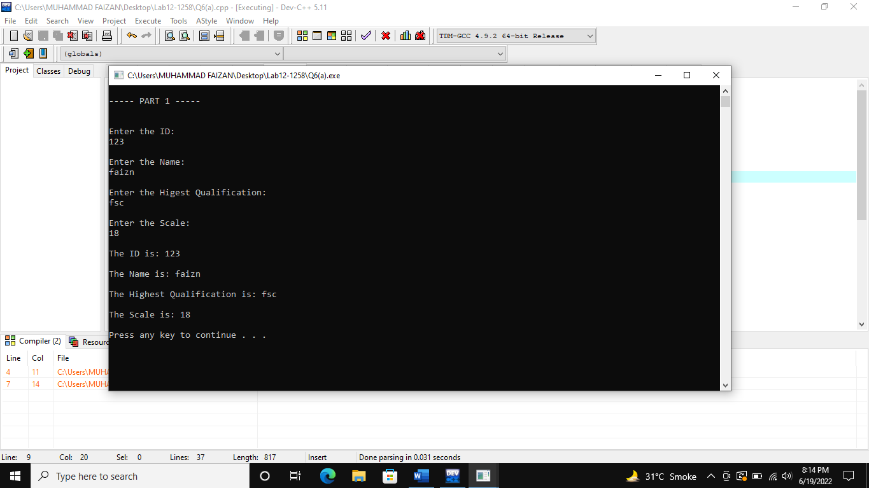

**(Q6(b))**

#include<iostream>

#include<cstring>

using namespace std;

struct Teacher {

int ID = 0;

char name[50];

char HQ[100];

int scale = 0;

};

int main()

{

cout << "\n----- PART 2 -----\n" << endl;

Teacher *T1, t1;

T1 = &t1;

T1->ID = 1001;

strcpy(T1->name, "asdf fs");

strcpy(T1->HQ, "BSCS");

T1->scale = 18;

cout << "\nThe ID is: " << T1->ID << endl;

cout << "\nThe Name is: " << T1->name << endl;

cout << "\nThe Highest Qualification is: " << T1->HQ << endl;

cout << "\nThe Scale is: " << T1->scale << endl;

cout << endl;

system("pause");

return 0;

}

**Output**

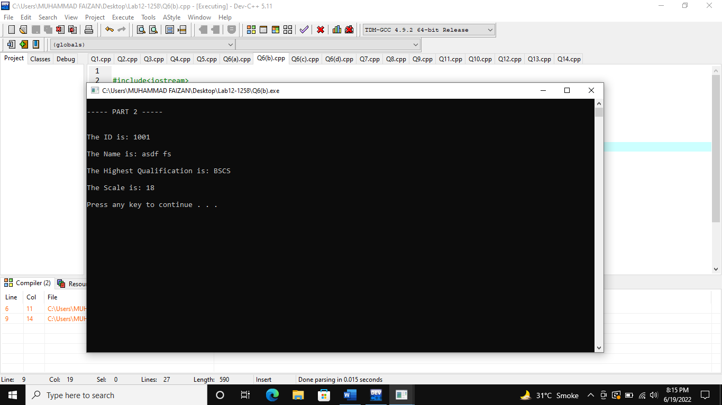

**(Q6(c))**

#include<iostream>

#include<cstring>

using namespace std;

struct Teacher {

int ID = 0;

char name[50];

char HQ[100];

int scale = 0;

};

int main()

{

cout << "\n----- PART 3 -----\n" << endl;

Teacher *T1 = new Teacher;

T1->ID = 1001;

strcpy(T1->name, "asdf fs");

strcpy(T1->HQ, "BSCS");

T1->scale = 18;

cout << "\nThe ID is: " << T1->ID << endl;

cout << "\nThe Name is: " << T1->name << endl;

cout << "\nThe Highest Qualification is: " << T1->HQ << endl;

cout << "\nThe Scale is: " << T1->scale << endl;

cout << endl;

system("pause");

return 0;

}

**Output**

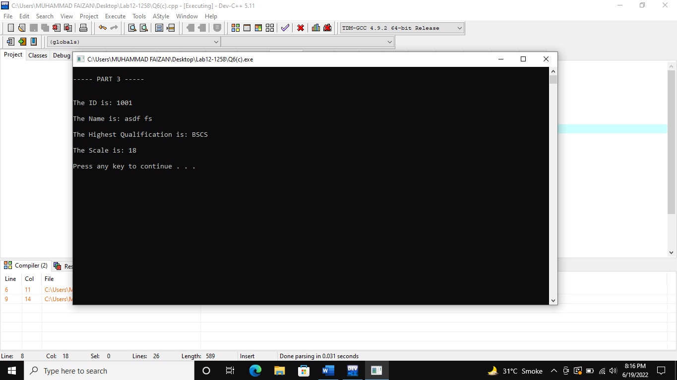

**(Q6(d))**

#include<iostream>

#include<cstring>

using namespace std;

struct Teacher {

int ID = 0;

char name[50];

char HQ[100];

int scale = 0;

};

void line()

{

for (int i = 0; i < 20; i++)

{

cout << "---";

}

}

int main()

{

cout << "\n----- PART 4 -----\n" << endl;

Teacher T1[5];

for (int i = 0; i < 5; i++)

{

cout << endl;

line();

cout << "\nEnter the " << i+1 << " ID: " << endl;

cin >> T1[i].ID;

cin.ignore();

cout << "\nEnter the " << i + 1 << " Name: " << endl;

cin.getline(T1[i].name, 50);

cout << "\nEnter the " << i + 1 << " Higest Qualification: " << endl;

cin.getline(T1[i].HQ, 100);

cout << "\nEnter the " << i + 1 << " Scale: " << endl;

cin >> T1[i].scale;

}

line();

cout << "\n" << endl;

for (int i = 0; i < 5; i++)

{

line();

cout << "\nThe " << i + 1 << " ID is: " << T1[i].ID << endl;

cout << "\nThe " << i + 1 << " Name is: " << T1[i].name << endl;

cout << "\nThe " << i + 1 << " Highest Qualification is: " << T1[i].HQ << endl;

cout << "\nThe " << i + 1 << " Scale is: " << T1[i].scale << endl;

}

cout << endl;

system("pause");

return 0;

}

**Output**

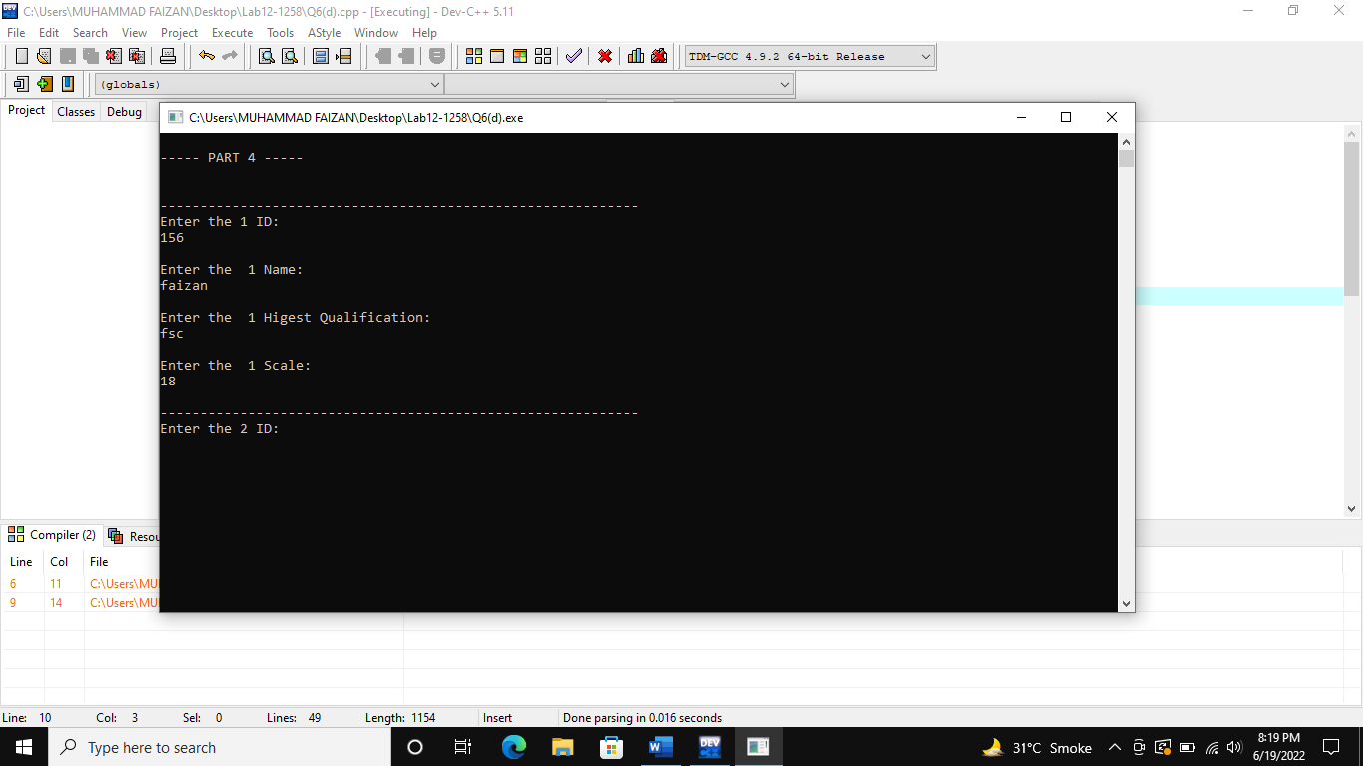

**(Q7)**

#include<iostream>

#include<cstring>

using namespace std;

class book

{

private:

int Isbn,price,pageno;

char title[50],mainarea[50],subarea[50];

public:

void input()

{

cout<<"Enter ISBN: ";

cin>>Isbn;

cout<<"Enter Title: ";

cin>>title;

cout<<"Enter Page No: ";

cin>>pageno;

cout<<"Enter Main area: ";

cin>>mainarea;

cout<<"Enter subarea: ";

cin>>subarea;

cout<<"Enter Price: ";

cin>>price;

}

void output()

{

cout<<"ISBN is: "<<Isbn<<endl;

cout<<"Title is: "<<title<<endl;

cout<<"Page no is: "<<pageno<<endl;

cout<<"Main Area is: "<<mainarea<<endl;

cout<<"Sub Area is: "<<subarea<<endl;

cout<<"Price is: "<<price<<endl;

}

};

int main()

{

book a[5];

for(int i=0;i<=4;i++)

{

a[i].input();

a[i].output();

}

cout<<endl;

}

**Output**

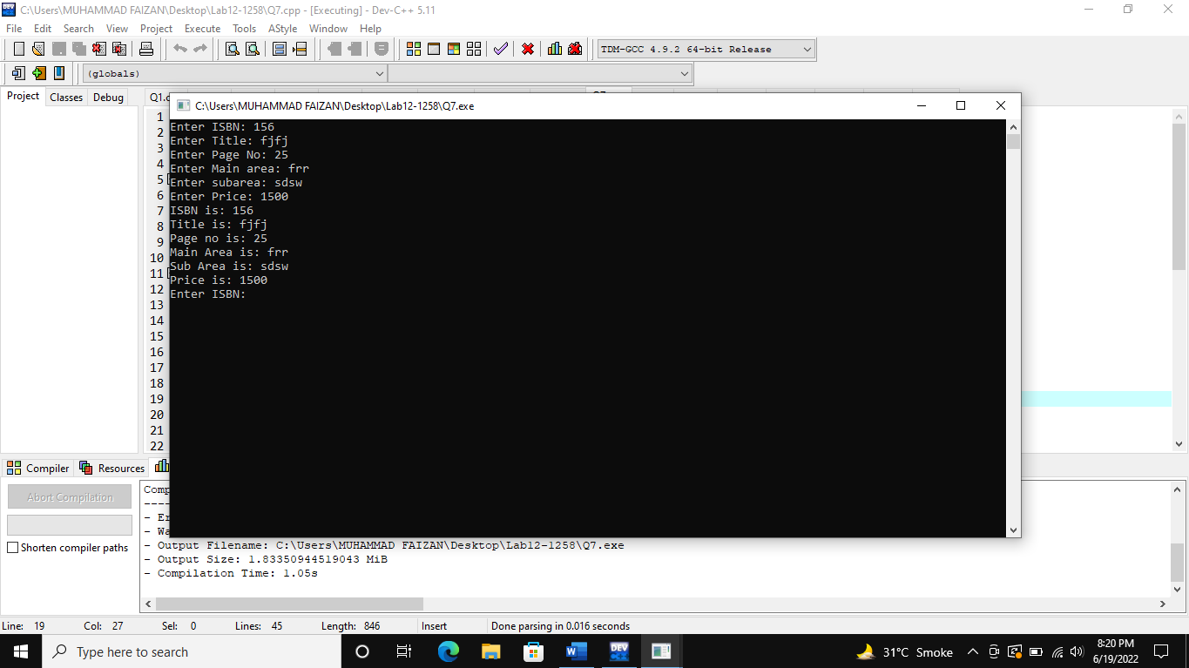

**(Q8)**

#include<iostream>

#include<cstring>

using namespace std;

class car

{

private:

int modelyear;

float kilometer;

char company[30],modelname[30];

public:

void input()

{

cout<<"Enter Company Name ";

cin>>company;

cout<<"Enter Mode Name: ";

cin>>modelname;

cout<<"Enter Model Year: ";

cin>>modelyear;

cout<<"Enter Kilometer driven: ";

cin>>kilometer;

}

void output()

{

cout<<"Company Name: "<<company<<endl;

cout<<"Model Name: "<<modelname<<endl;

cout<<"Model Year: "<<modelyear<<endl;

cout<<"Kilometer Driven: "<<kilometer<<endl;

}

};

int main()

{

car c;

c.input();

cout<<endl;

c.output();

}

**Output**

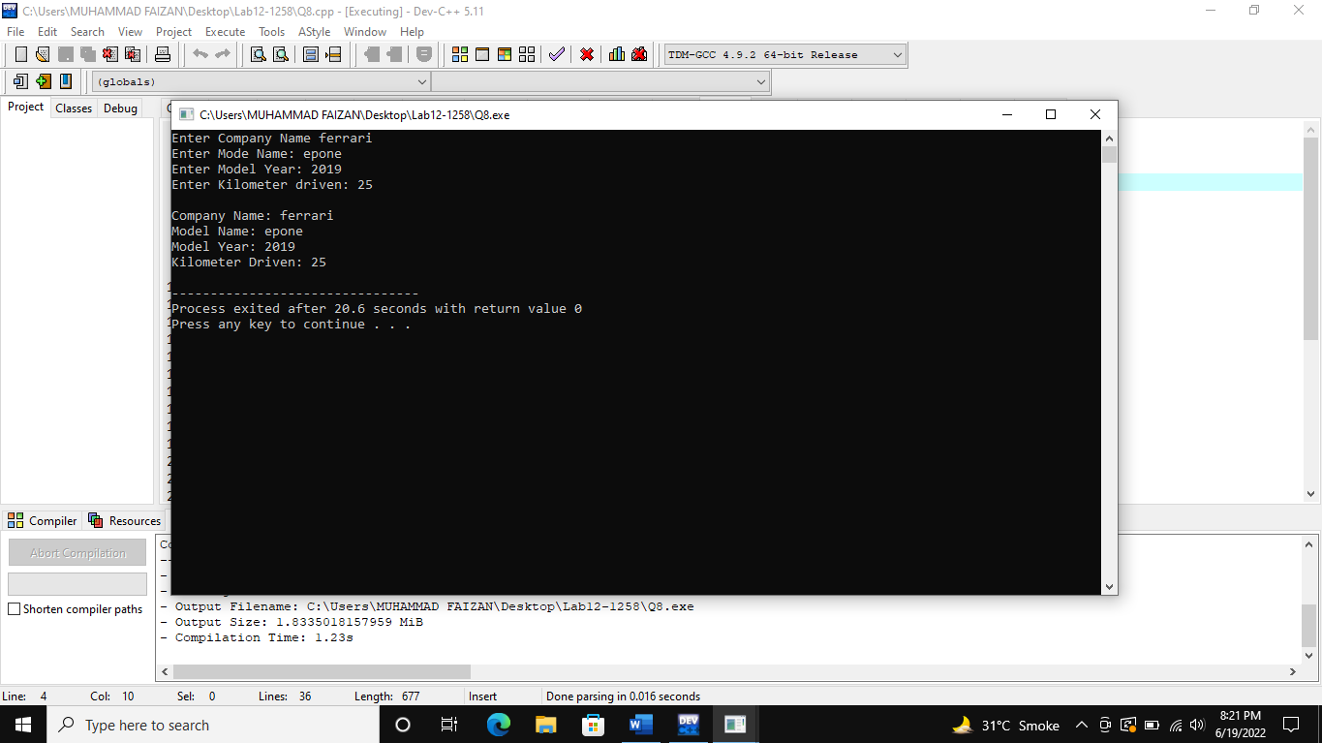

**(Q9)**

#include<iostream>

#include<cstring>

using namespace std;

class Students {

private:

char RegNumber[30];

char Name[30];

int Semester = 0;

char Degree[30];

char Department[30];

float Gpa = 0.0;

public:

// Functions of Reg Number //

void set_reg_number()

{

cout << "Enter Reg Number: ";

cin.getline(RegNumber, 30);

}

void get_reg_number()

{

cout << "\nThe Reg Number is: " << RegNumber << endl;

}

// Functions of Name //

void set_name()

{

cout << "Enter Name of Student: ";

cin.getline(Name, 30);

}

void get_name()

{

cout << "\nThe Name is: " << Name << endl;

}

// Functions of Semester //

void set_semester()

{

cout << "Enter Number of Semester: ";

cin >> Semester;

cin.ignore();

}

void get_semester()

{

cout << "\nThe Semester is: " << Semester << endl;

}

// Functions of Degree //

void set_degree()

{

cout << "Enter the Degree: ";

cin.getline(Degree, 30);

}

void get_degree()

{

cout << "\nThe Degree is: " << Degree << endl;

}

// Functions of Department //

void set_department()

{

cout << "Enter the Department: ";

cin.getline(Department, 30);

}

void get_department()

{

cout << "\nThe Department is: " << Department << endl;

}

// Functions of GPA //

void set_gpa()

{

cout << "Enter the GPA: ";

cin >> Gpa;

cin.ignore();

}

void get_gpa()

{

cout << "\nThe GPA is: " << Gpa << endl;

}

// Functions of Display //

void display()

{

get_reg_number();

get_name();

get_semester();

get_degree();

get_department();

get_gpa();

}

};

void line()

{

for (int i = 0; i < 20; i++)

{

cout << "---";

}

}

int main()

{

Students s1, s2;

// Input Info of Object 1 //

cout << endl;

line();

cout << endl;

s1.set_reg_number();

cout << endl;

s1.set_name();

cout << endl;

s1.set_semester();

cout << endl;

s1.set_degree();

cout << endl;

s1.set_department();

cout << endl;

s1.set_gpa();

cout << endl;

// Display Info of Object 1 //

line();

s1.display();

cout << "\n" << endl;

// Input Info of Object 2 //

cout << endl;

line();

cout << endl;

s2.set_reg_number();

cout << endl;

s2.set_name();

cout << endl;

s2.set_semester();

cout << endl;

s2.set_degree();

cout << endl;

s2.set_department();

cout << endl;

s2.set_gpa();

cout << endl;

// Display Info of Object 2 //

line();

s2.display();

cout << endl;

cout << endl;

system("pause>0");

return 0;

}

**Output**

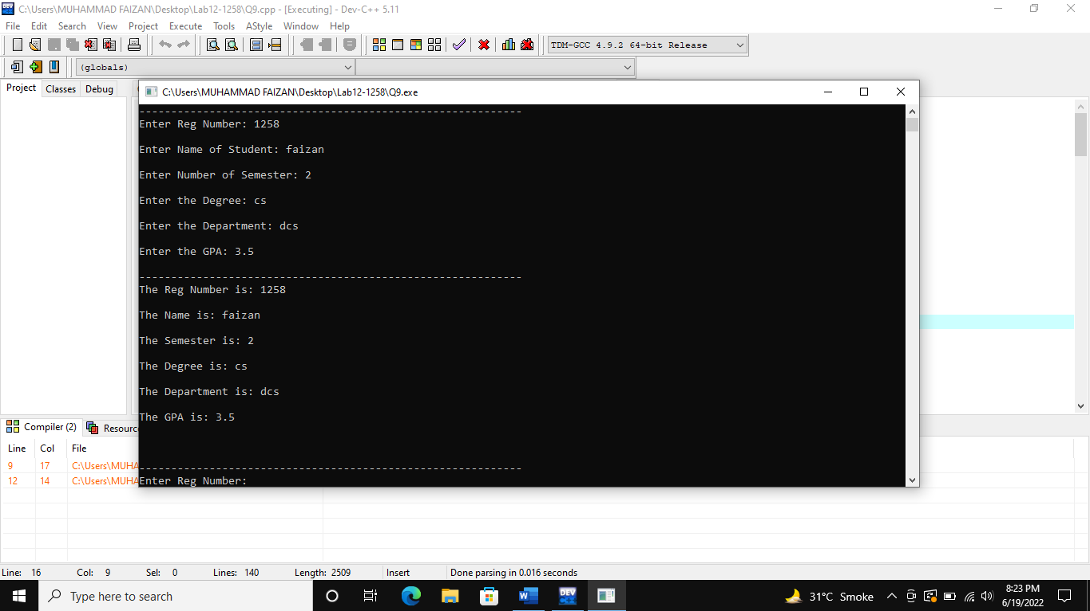

**(Q10)**

#include<iostream>

#include<cstring>

using namespace std;

class Book {

public:

int ISBN = 0;

float Price = 0.0;

char Title[50];

char MainArea[50];

char SubArea[100];

int No_of_pages = 0;

void input();

void output();

};

void Book::input()

{

cout << "Enter the ISBN: " << endl;

cin >> ISBN;

cin.ignore();

cout << "\nEnter the Title: " << endl;

cin.getline(Title, 50);

cout << "\nEnter the Main Area: " << endl;

cin.getline(MainArea, 100);

cout << "\nEnter the Sub Area: " << endl;

cin.getline(SubArea, 100);

cout << "\nEnter the Price: " << endl;

cin >> Price;

cout << "\nEnter the No of Pages: " << endl;

cin >> No_of_pages;

}

void Book::output()

{

cout << "\nThe ISBN Number is: " << ISBN << endl;

cout << "\nThe Title of Book is: " << Title << endl;

cout << "\nThe Main Area of Book is: " << MainArea << endl;

cout << "\nThe Sub Area of Book is: " << SubArea << endl;

cout << "\nThe Price of Book is: " << Price << endl;

cout << "\nThe No. Of Pages are: " << No_of_pages << endl;

}

void line()

{

for (int i = 0; i < 20; i++)

{

cout << "---";

}

}

int main()

{

Book b1;

b1.input();

line();

b1.output();

cout << endl;

system("pause>0");

return 0;

}

**Output**

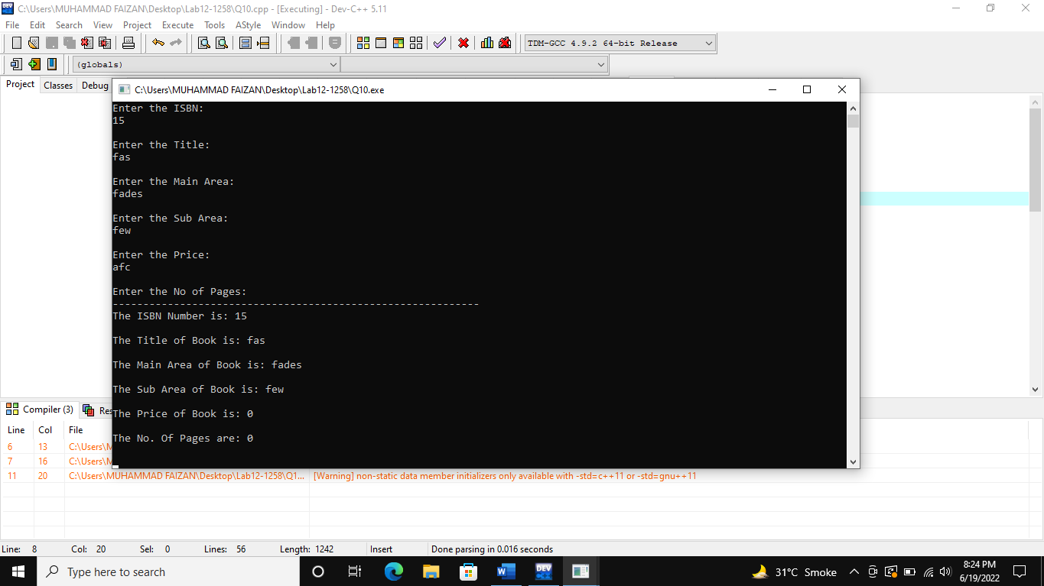

**(Q11)**

#include<iostream>

using namespace std;

class Computer {

private:

char brandname[50];

float speed = 0.0;

int memorysize = 0;

public:

void input();

void output();

};

void Computer::input()

{

cout << "\nEnter the Brand Name: " << endl;

cin.getline(brandname, 50);

cout << "\nEnter the Speed: " << endl;

cin >> speed;

cout << "\nEnter the Memory Size: " << endl;

cin >> memorysize;

}

void Computer::output()

{

cout << "\nThe Name of the Brand is: " << brandname << endl;

cout << "\nThe Speed of the Computer is: " << speed << " Ghz" << endl;

cout << "\nThe Memory Size of the Computer is: " << memorysize << " GB" << endl;

}

int main()

{

Computer *c1, c2;

c1 = &c2;

c1->input();

cout << endl;

c1->output();

cout << endl;

system("pause");

return 0;

}

**Output**

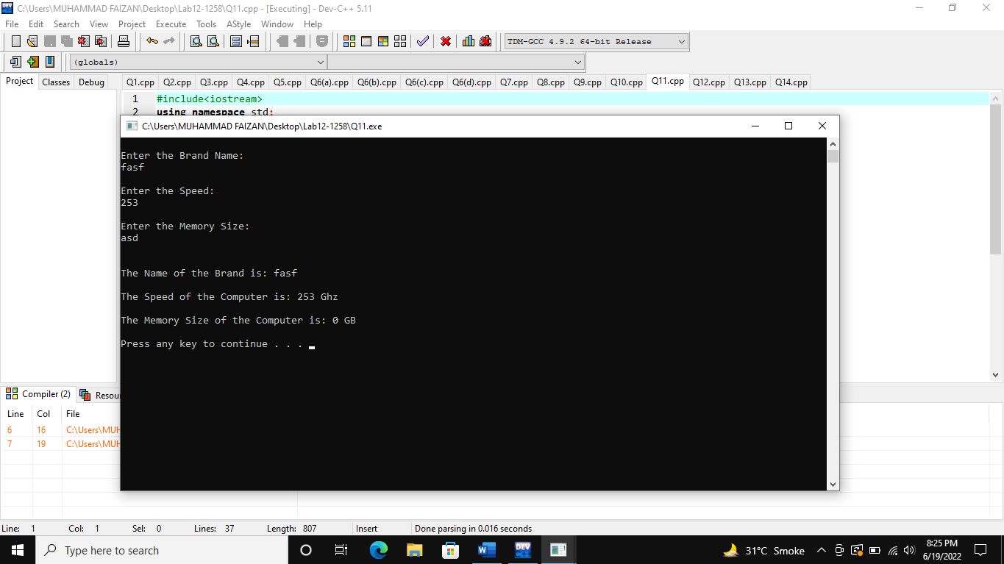

**(Q12)**

#include<iostream>

using namespace std;

class Computer {

private:

char brandname[50];

float speed = 0.0;

int memorysize = 0;

public:

void input();

void output();

};

void Computer::input()

{

cout << "\nEnter the Brand Name: " << endl;

cin.getline(brandname, 50);

cout << "\nEnter the Speed: " << endl;

cin >> speed;

cout << "\nEnter the Memory Size: " << endl;

cin >> memorysize;

}

void Computer::output()

{

cout << "\nThe Name of the Brand is: " << brandname << endl;

cout << "\nThe Speed of the Computer is: " << speed << " Ghz" << endl;

cout << "\nThe Memory Size of the Computer is: " << memorysize << " GB" << endl;

}

int main()

{

Computer *c1 = new Computer;

c1->input();

cout << endl;

c1->output();

cout << endl;

system("pause");

return 0;

}

**Output**

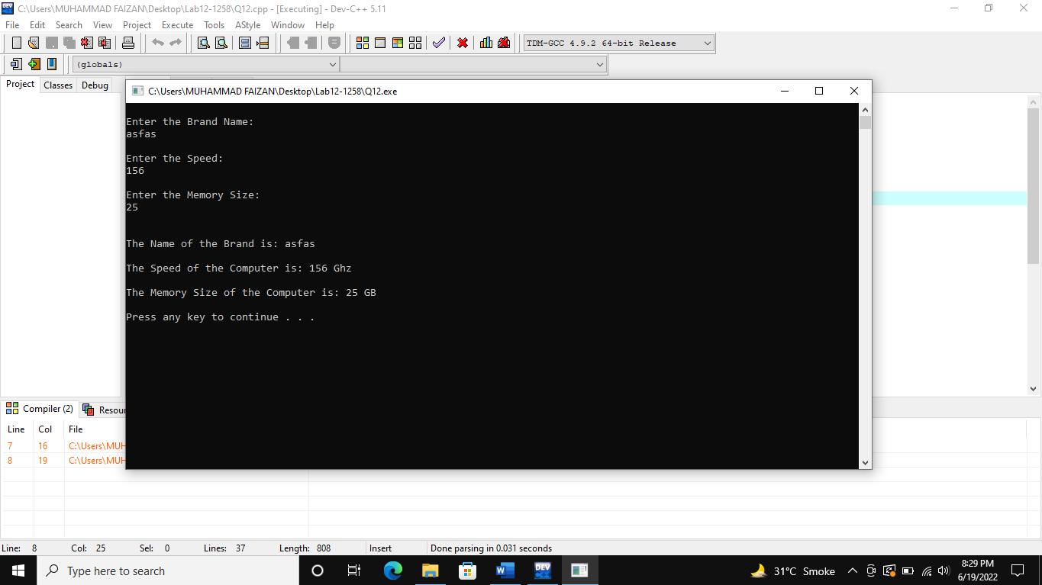

**(Q13)**

#include<iostream>

using namespace std;

class Computer {

private:

char brandname[50];

float speed = 0.0;

int memorysize = 0;

public:

void input();

void output();

};

void Computer::input()

{

cout << "\nEnter the Brand Name: ";

cin.getline(brandname, 50);

cout << "Enter the Speed: ";

cin >> speed;

cout << "Enter the Memory Size: ";

cin >> memorysize;

cin.ignore();

}

void Computer::output()

{

cout << "\nThe Name of the Brand is: " << brandname << endl;

cout << "The Speed of the Computer is: " << speed << " Ghz" << endl;

cout << "The Memory Size of the Computer is: " << memorysize << " GB" << endl;

}

void line()

{

for (int i = 0; i < 20; i++)

{

cout << "---";

}

}

int main()

{

Computer c1[5];

for (int i = 0; i < 5; i++)

{

line();

c1[i].input();

}

for (int i = 0; i < 5; i++)

{

line();

cout << "\nComputer " << i+1 << " Info"<< endl;

c1[i].output();

}

cout << endl;

system("pause");

return 0;

}

**Output**

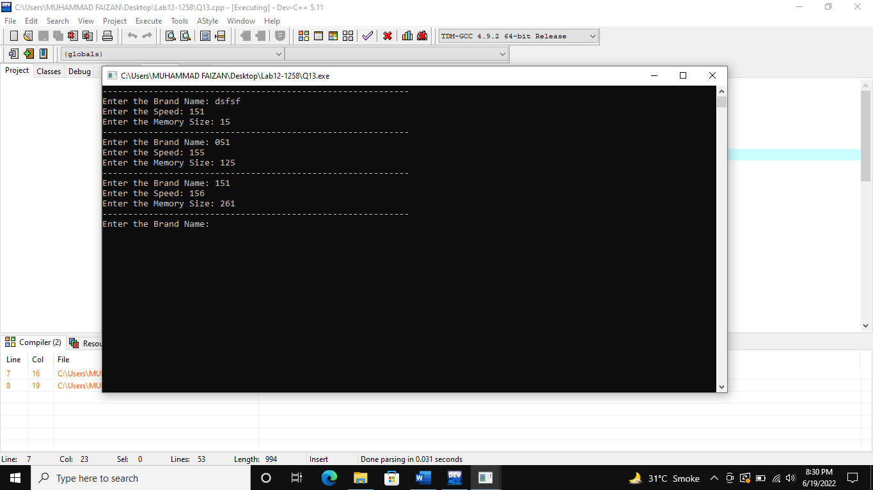

**(Q14)**

#include<iostream>

#include<cstring>

using namespace std;

class TelephoneDirectory

{

private:

int ID = 0;

char FirstName[50];

char LastName[50];

char Telephone[20];

char Mobile[20];

char Email[50];

char City[50];

public:

void add_record(TelephoneDirectory*);

void display_all(TelephoneDirectory*);

void search_record(TelephoneDirectory*);

};

void line()

{

for (int i = 0; i < 20; i++)

{

cout << "---";

}

}

void TelephoneDirectory::add_record(TelephoneDirectory* p)

{

for (int i = 0; i < 10; i++)

{

line();

cout << "\nEnter the ID of " << i + 1 << " Contact: ";

cin >> p[i].ID;

cin.ignore();

cout << "\nEnter the First Name of " << i + 1 << " Contact: ";

cin.getline(p[i].FirstName, 50);

cout << "\nEnter the Last Name of " << i + 1 << " Contact: ";

cin.getline(p[i].LastName, 50);

cout << "\nEnter the TelePhone Number of " << i + 1 << " Contact: ";

cin.getline(p[i].Telephone, 20);

cout << "\nEnter the Mobile Number of " << i + 1 << " Contact: ";

cin.getline(p[i].Mobile, 20);

cout << "\nEnter the Email of " << i + 1 << " Contact: ";

cin.getline(p[i].Email, 50);

cout << "\nEnter the City of " << i + 1 << " Contact: ";

cin.getline(p[i].City, 50);

cout << endl;

}

}

void TelephoneDirectory::display_all(TelephoneDirectory* a)

{

for (int i = 0; i < 10; i++)

{

line();

cout << "\n\n\t\tCONTACT " << i + 1 << " INFORMATION\t\t\n" << endl;

cout << "\nThe ID of " << i + 1 << " Contact is: " << a[i].ID << endl;

cout << "\nThe First Name of " << i + 1 << " Contact is: " << a[i].FirstName << endl;

cout << "\nThe Last Name of " << i + 1 << " Contact is: " << a[i].LastName << endl;

cout << "\nThe Telephone Number of " << i + 1 << " Contact is: " << a[i].Telephone << endl;

cout << "\nThe Mobile Number of " << i + 1 << " Contact is: " << a[i].Mobile << endl;

cout << "\nThe Email of " << i + 1 << " Contact is: " << a[i].Email << endl;

cout << "\nThe City of " << i + 1 << " Contact is: " << a[i].City << endl;

cout << endl;

}

cout << endl;

}

void TelephoneDirectory::search_record(TelephoneDirectory* a)

{

char search_name[50];

cin.ignore();

cout << "\nEnter Name to Search Record of Contact: ";

cin.getline(search_name, 50);

for (int i = 0; i < 10; i++)

{

if (strcmp(search_name, a[i].FirstName) == 0)

{

cout << "\nThe ID of " << i + 1 << " Contact is: " << a[i].ID << endl;

cout << "\nThe First Name of " << i + 1 << " Contact is: " << a[i].FirstName << endl;

cout << "\nThe Last Name of " << i + 1 << " Contact is: " << a[i].LastName << endl;

cout << "\nThe Telephone Number of " << i + 1 << " Contact is: " << a[i].Telephone << endl;

cout << "\nThe Mobile Number of " << i + 1 << " Contact is: " << a[i].Mobile << endl;

cout << "\nThe Email of " << i + 1 << " Contact is: " << a[i].Email << endl;

cout << "\nThe City of " << i + 1 << " Contact is: " << a[i].City << endl;

cout << endl;

}

}

cout << endl;

}

void menu()

{

cout << "\n\n\t\tTelePhone Directory\t\t\n\n";

cout << "\t\t1.\tAdd Record." << endl;

cout << "\t\t2.\tDisplay All." << endl;

cout << "\t\t3.\tSearch Record." << endl;

cout << "\t\t4.\tExit." << endl;

}

int main()

{

TelephoneDirectory contact[10];

int op;

while (true)

{

system("cls");

menu();

cout << "\nEnter the Option:" << endl;

cin >> op;

switch (op)

{

case 1:

{

contact->add_record(contact);

break;

}

case 2:

{

contact->display_all(contact);

break;

}

case 3:

{

contact->search_record(contact);

break;

}

case 4:

{

return 0;

}

default:

{

cout << "\nINVALID OPTION!!" << endl;

}

}

system("pause");

}

cout << endl;

system("pause");

return 0;

}

**Output**

